TC-PM-011
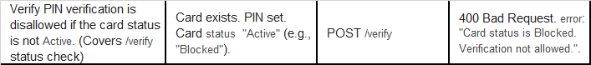
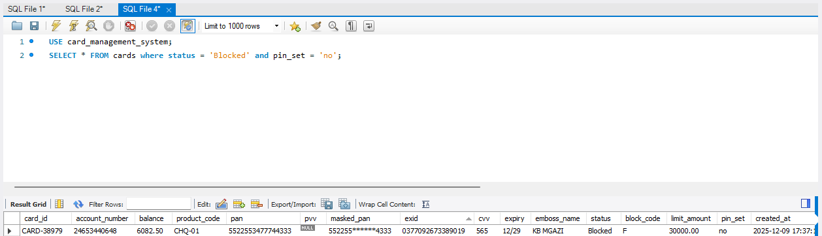
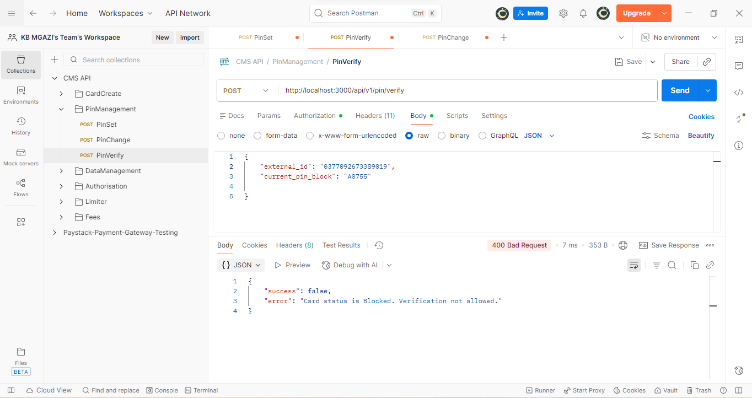
Request:
{
"external_id": "0377092673389019",
"current_pin_block": "A0755"

}
Response:
{
"success": false,
"error": "Card status is Blocked. Verification not allowed."
}

